New Additions to the DALI PHANTOM K-Series

Now available in North America, DALI introduces the new premium K-Series in-ceiling speakers along with the rectangular and H-R series in-wall speakers

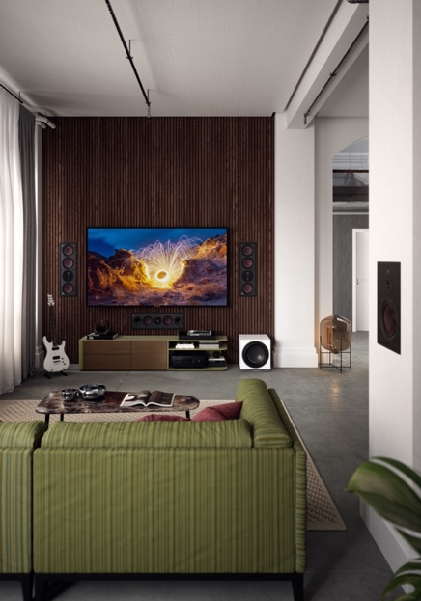
Toronto, Canada, June 2, 2022— Lenbrook Americas announces the latest additions in the DALI PHANTOM Series, an expansion of the comprehensive range of CI loudspeakers with four new models that offer customizable Hi-Fi audio solutions without sacrificing high-quality sound performance. The DALI PHANTOM K-60 and K-80 are premium in-ceiling speakers while the PHANTOM H-60R and H-80R in-wall speakers offer a functional rectangular shape. All speakers are available with white paintable grilles and the following prices; Phantom K-60 (USD $549ea), Phantom K-80 (USD $699ea), PHANTOM H-60 R (USD $549ea) and the PHANTOM H-80R (USD $649ea).

The DALI PHANTOM K-Series
The K-series speakers are versatile in-ceiling units that offer true Hi-Fi performance whether they’re part of a stereo system, multi-channel home-cinema setup or as a discreet distributed sound solution for an entire home. The 6 ½” PHANTOM K-60 and 8” PHANTOM K-80 feature custom-designed drivers and components that draw from decades of experience developing some of the best Hi-Fi loudspeakers in the world. The woofers have improved diaphragm behavior, thanks to the signature DALI wood-fiber cones— a first for the brand’s in-ceiling speakers. A new optimized magnet system also provides better low-end response.

PHANTOM K-80 with front grille

The K-series uses the same cut-out dimensions as their E-series siblings, giving DALI customers an easy upgrade path to even better sound. A uniquely designed magnetic grille gives a discreet and modern look that blends into any space. The K-series also has custom-designed tweeters that can be tilted towards the listener to optimize off-axis performance. Two level switches allow the sound to be tweaked to the exact application or to personal taste.

Accessories for the K-series include an optional square grille to suit personal preferences or to match other in-ceiling features like lights, vents, etc. Back boxes for both the K-60 and K-80 are also available, which offer physical protection from debris and dirt, as well as moisture in areas such as bathrooms, while also delivering acoustic benefits by eliminating sound bleeding into other rooms. The back boxes can be retrofitted so there is flexibility within each custom install. Coming this fall, pre-construction kits will be available as well.

The DALI PHANTOM H Rectangular Series

The 6 ½” PHANTOM H-60 R and 8” H-80 R are premium in-wall Hi-Fi loudspeakers in a rectangular form. With a soft dome tweeter, wood fiber cones, and MDF baffle, the new H-R speakers use the same components as the DALI PHANTOM H-60 and H-80 models, offering the same high-end performance with a more conventional form factor. DALI aims to broaden its application with the H-R series by making it easier to install the series into new or pre-existing stereo arrangements.

PHANTOM H-80 R with front grille

The powerful low-loss magnet system delivers precision and timing to the low frequencies and the ultra- lightweight soft dome tweeter adds great resolution to the high frequencies. Together they blend into a very coherent, highly detailed, clear and natural soundstage. The PHANTOM H-80R is a true full range speaker that needs no supplement subwoofer— its focus is on true hi-fi sound, versatility, and flexibility. “We believe that with better sound you get a better life,” says DALI CEO, Lars Worre.

About DALI
DALI, (Danish Audiophile Loudspeaker Industries), was established in 1983, and grew out of Scandinavia’s leading audio retail chain. Now distributed in 65 countries, and with more than 35 years of experience and global recognition, DALI holds unwavering dedication to sound that has advanced the state of the art, inspiring music and cinema lovers and challenging the competition to catch up. DALI is driven by raw passion for music and an honest reproduction in the domestic environment. Continuous development and refinement of new technologies remains core to DALI’s quest to create the best loudspeakers in the world. For more information, visit DALI-SPEAKERS.com

About Lenbrook
The Lenbrook Group of Companies is a privately held Canadian corporation who are the owners of NAD Electronics, PSB Speakers, Bluesound and Bluesound Professional. Formed in 1978, Lenbrook initially was a national distributor of electronics and communications products in Canada and has grown to become a leading global supplier to over 80 countries around the world.

Lenbrook Americas, a wholly owned subsidiary of Lenbrook International, is responsible for the sales and marketing of NAD Electronics, PSB Speakers, Bluesound and DALI in both the U.S. and Canada. Additionally, it also distributes Tivoli Audio and Master & Dynamic in Canada.

Corporate & Media Contact
Nadia Lildhar
Marketing, Lenbrook International
media@lenbrookamericas.com

PR Contacts
Shelby Coppola
OLEX Communications
shelby@olexcommunications.us

Jeffrey Touzeau
OLEX Communications
jeff@olexcommunications.us

Links:
DALI Website: http://www.dali-speakers.com
DALI Image Library: https://brandfolder.com/dali/press
Lenbrook Americas Website: http://lenbrookamericas.com

# # #

